# “CSS ASSIGNMENT”

# ****Q1. What are benefits of using CSS?****

## ****ANS: Benefits of using CSS are mentioned below:****

1. Better user experience.
2. By using CSS we set color of text,background-color,etc.
3. we can use same sheet to multiple HTML pages.
4. Easy to customize the page.

# Q2. What are the disadvantages of CSS?

## ANS: Disadvantages of using CSS are mentioned below:

1. Create confusion between browser.
2. More code on the page.
3. Extra work for developers.

# Q3. What is difference between CSS2 and CSS3?

Ans.

|  |  |
| --- | --- |
| CSS 2 | CSS3 |
| * It has less styling option comparatively. | * It has more styling option comparatively. |
| * Css2 supported in less browser. | * Css3 is supported in more browser. |
| * Less fonts available in Css2 | * More fonts available in Css3 |

# Q4. Name a few CSS style components.

Ans: style components are mentioned below:-

1. Selectors: Selectors are html element, html tag, id and class.
2. Properties: Properties are used to style the selector.

For example, font-size , width , background-color etc.

1. Values: Value is given to the property. This value indicates how to style the property.

# Q5. What do you understand by CSS opacity?

Ans: Opacity is a property of CSS. It defines the transparency of an elemnt.

By using this property we can set opacity accordingly. It can be fully

transparent , medium, or fully solid.

Note : *Opacity of an element can be set in range between 0 to 1.*

# Q6. How can the background color of an element be changed?

Ans: In order to change the background color of an element in CSS, We

We have to use the CSS “background-color property ”. By using this

Property we can change the background color of any element by gi-

-ving value to the property.

# Input:

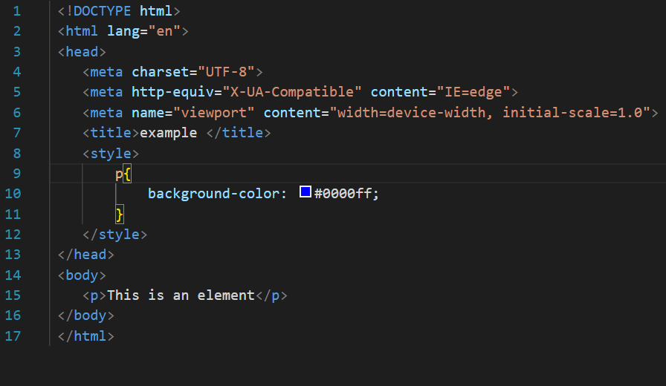

# Output:

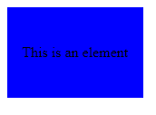

# Q7. How can image repetition of the backup be controlled?

Ans: In CSS if we want to set background image in an element than by

default the image repeats itself to cover the size of element. In order

to stop repetition of an image we set “background-repeat” property to

“no-repeat”.

# Input:-

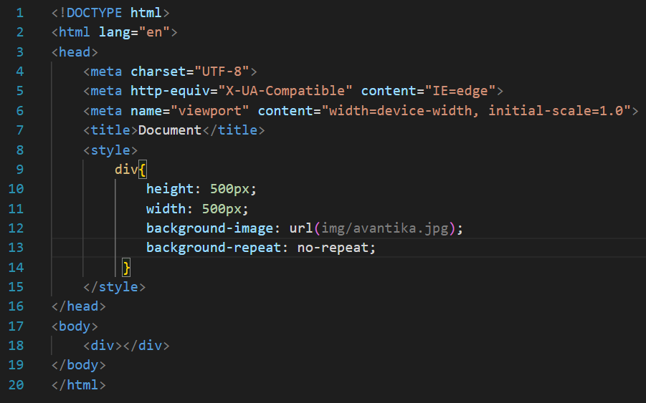

Output:-before applying background repeat to “no-repeat”

# 

Output:After applying background repeat to “no-repeat”

# 

# Q8. What is the use of the background-position property?

Ans: “Background-position” property is used to set the position of background

image. By default the image will appear at top left corner of an element.

We can set background-position by applying directions given below:-

* Top .

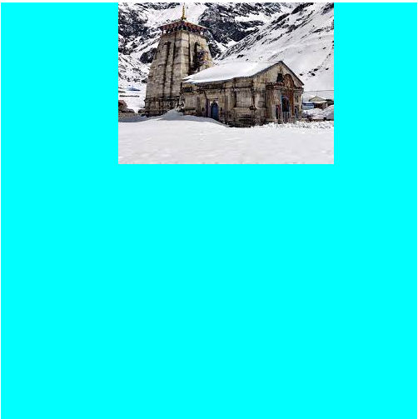

* Bottom.

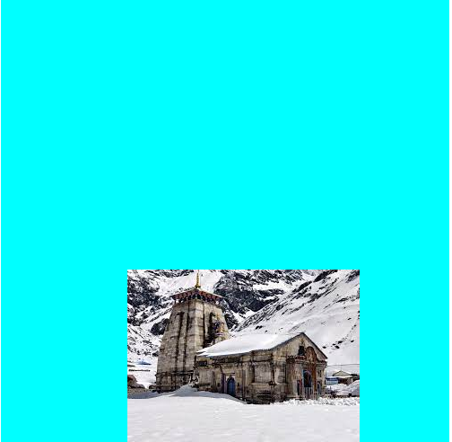

* Center.

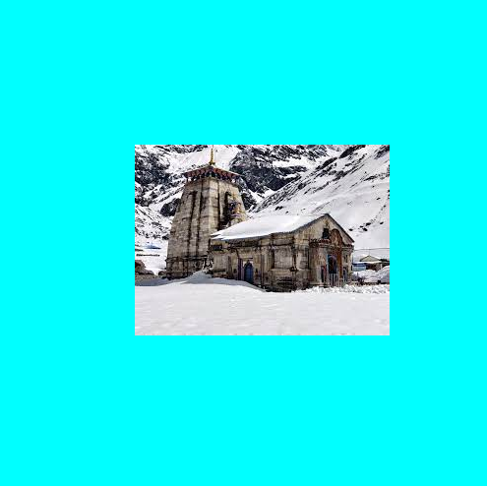

* Right.

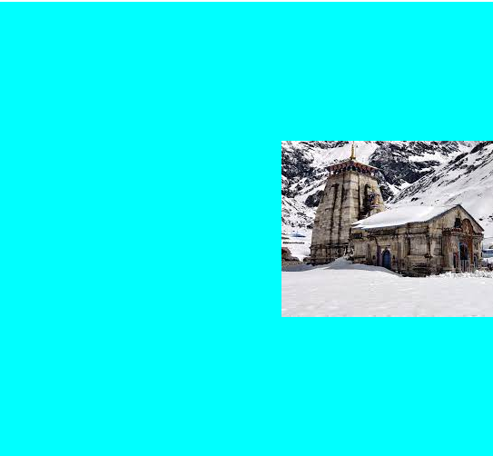

* Left.

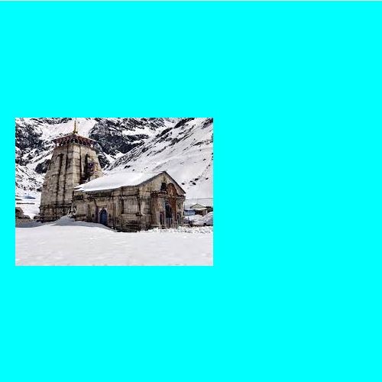

# Q9. Which property controls the image scroll in the background?

Ans: The image scroll in the background can be controlled by the CSS

property called “overflow”. By assigning “scroll" value to overflow

property we can control image scroll in the background.

# Input:

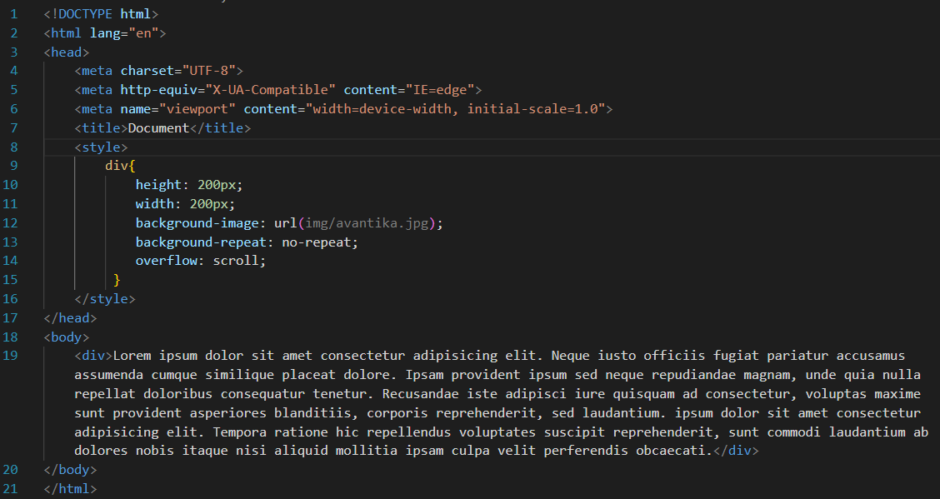

# Output:-

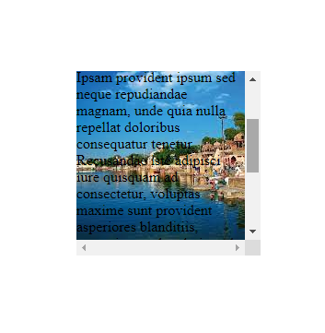

# Q11. Why should background and color be used as separate properties?

Ans. color is referring to the text color in that element. And background is

a shorthand for many properties. If background and color both used

together then property will become complex. By using separately

we can assign them different color. It will be easier for user to read.

## Example:-



# Q11. How to center block elements using CSS1?

Ans: By using CSS1 we can center a block element with the help of the

<center> tag.

# Input:-

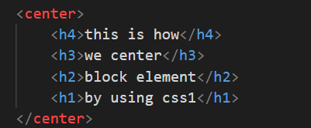

## Output:-

# Q12. How to maintain the CSS specifications?

Ans. The CSS specifications are maintained by the World Wide Web

Consortium(W3C).

# Q13. What are the ways to integrate CSS as a web page?

Ans. We can integrate CSS as a web page in three different ways.

* Inline CSS :By using Inline CSS in a in a style attribute

## Example:-

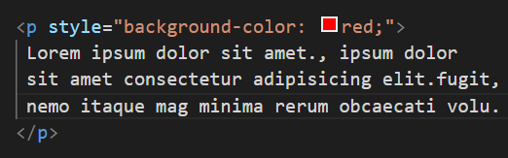

* internal style: By adding CSS in head section under style tag.

## Example:-

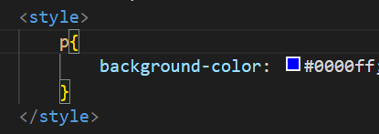

* External style:By giving link of an external stylesheet under the <head> tag.

## Example:-

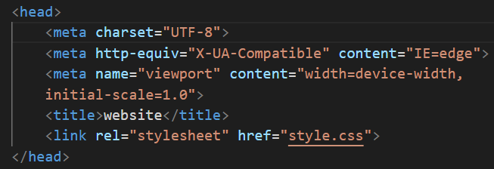

# Q14. What is embedded style sheets?

Ans: We can “embed style sheet” in head element under head element

of html. For embedding a style we have to write styles under <style>

</style> element. It helps us to write html & give style to html in same

Page.

## Example:-



# Q15. What are the “External style sheets”?

Ans: An “external style” means a separate document used for styling a

html webpage. It is linked to a html webpage by declaring the link.

This sheet under the head section of the same html document.

## Example:-



# Q16. What are the advantages and disadvantages of using external style sheets?

## Ans: Advantages of “External style sheet”

* We can use the same style to style multiple website.
* Classes can be created for use on multiple html element

types in many document.

## Disadvantages of “External style sheet”

* Your pages may not be rendered correctly if external

CSS is not properly loaded.

* For small numbers of style definitions it is not viable.

# Q17. What is the meaning of the CSS selector?

Ans: CSS seletors are used to target a particular element , id , or class

In html documents we want to style.

There are five types of selectors in CSS mentioned below:-

1. Universal selector *{“*” is used to target universal selector}.*
2. Element selector *{“Element’s name” is used to target Element selector}.*
3. Class selector *{“.” is used to target class selector}.*
4. id selector *{“#” is used to target id selector}.*
5. group selector *{“group of elment” are used to target group selector}.*

# Q18. What are the media types allowed by CSS?

Ans: All — for all media types

* print — for printers
* screen — for computer screens, tablets and, smart-

phones.

* speech — for screen readers that “read” the page out loud.

1. 320px — 480px: Mobile devices
2. 481px — 768px: iPads, Tablets
3. 769px — 1024px: Small screens, laptops
4. 1025px — 1200px: Desktops, large screens
5. 1201px and more —  Extra large screens,TV.

# Q19. What is CSS rule set?

Ans. h1{color:red;}

* Selector:The selector indicate which type of content is to be styled,

here “h1” is an element is a selector.

* Property:The property refers to the content that is to be modified by

CSS. Here the property is “color”.

* Value:The value refers to the specific value refers to the property.

Here the value is “red”.

# Q20. Create Layouts.

Ans:

Input:-

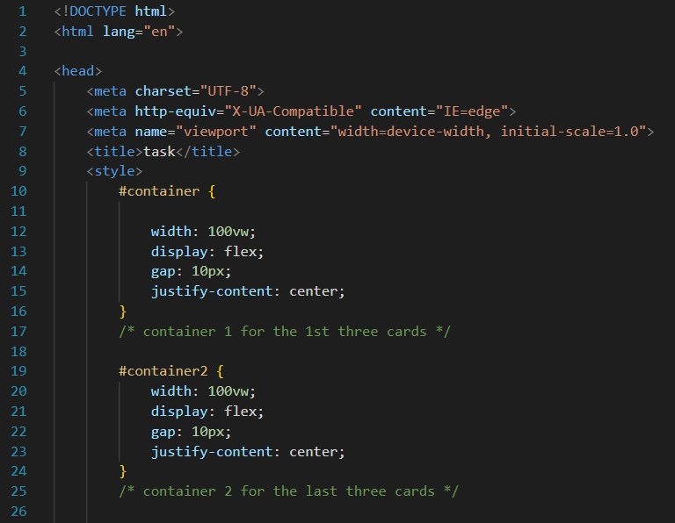

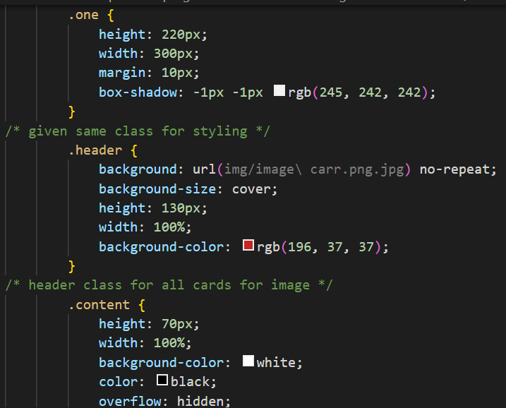

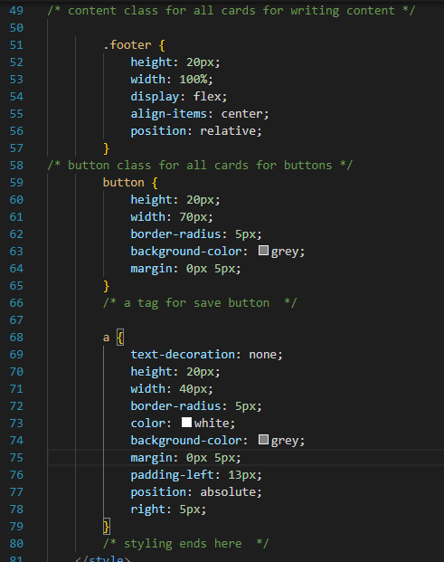

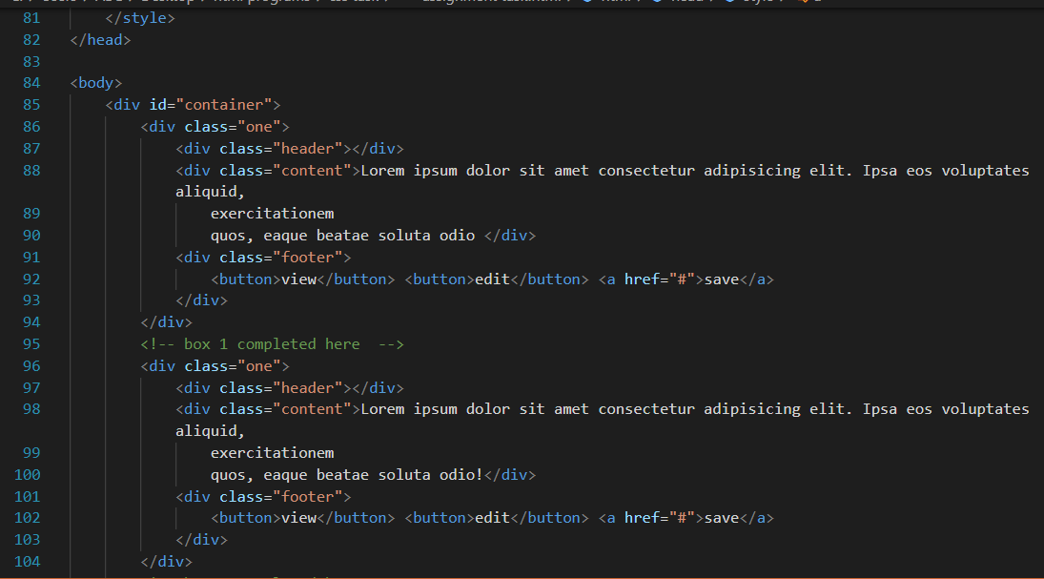

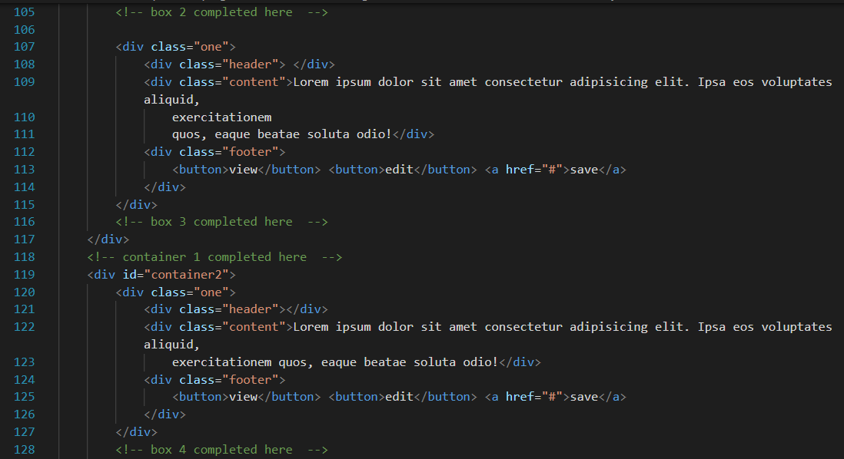

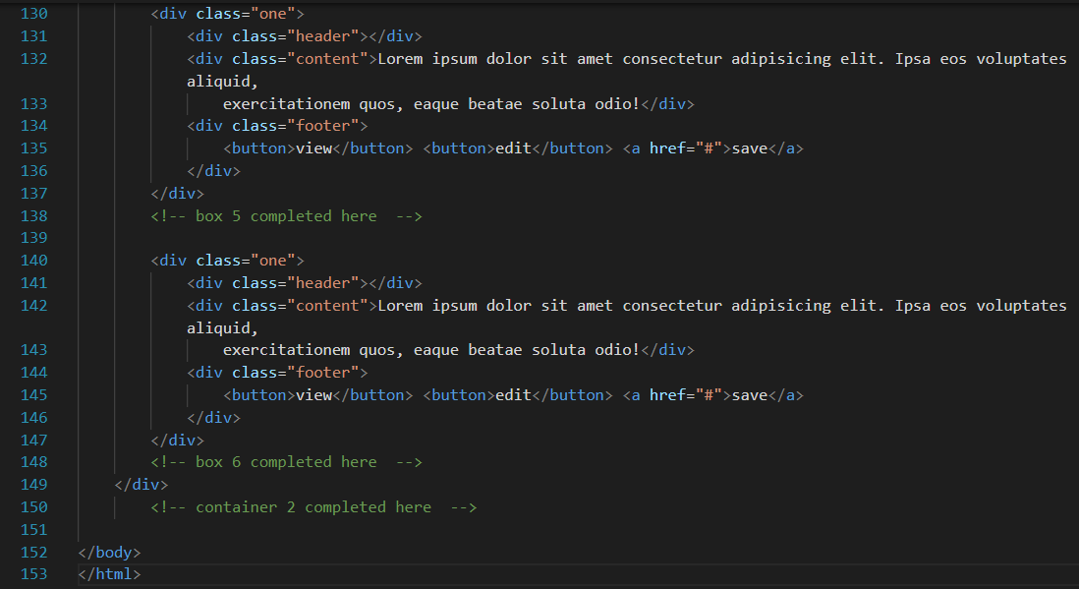

# Ouput:-

